|  |  |
| --- | --- |
| \\VFILERDPI\DPI-Home\OBRIENR2\My Documents\Downloads\PP logo.jpg |  |
| **COUNCIL ASSESSMENT REPORT**  NORTHERN REGIONAL PLANNING PANEL | |

|  |  |
| --- | --- |
| PANEL REFERENCE & DA NUMBER | PPSNTH – 165  DA-92-2022 |
| PROPOSAL | Warehouse or Distribution Centre - Construction of New Warehouse Building with Associated Office and Administration Area, On-Site Car parking and Associated Infrastructure |
| ADDRESS | 2 Cameron Drive, 8 Cameron Drive, 10 Cameron Drive, 12 Cameron Drive, 14 Cameron Drive, 15 Waller Avenue and 17 Waller Avenue ARMIDALE NSW 2350; to be collectively known as 2 Cameron Drive Armidale following consolidation of the seven (7) lots. |
| APPLICANT | Formline Group Pty Ltd |
| OWNER | Armidale Regional Council |
| DA LODGEMENT DATE | 01 July 2022 |
| APPLICATION TYPE | Development Application |
| REGIONALLY SIGNIFICANT CRITERIA | Section 3(b), Schedule 6 of *State Environmental Planning Policy (Planning Systems) 2021* :  **3 Council related development over $5 million**  *Development that has a capital investment value of more than $5 million if –*  *(b) the Council is the owner of the land on which the development is to be carried out* |
| CIV | $6,951,330 (excluding GST) |
| CLAUSE 4.6 REQUESTS | No |
| KEY SEPP/LEP | State Environmental Planning Policy (Planning Systems) 2021  State Environmental Planning Policy (Biodiversity and Conservation) 2021  State Environmental Planning Policy (Resilience and Hazards) 2021  State Environmental Planning Policy (Transport and Infrastructure) 2021  State Environmental Planning Policy (Industry and Employment) 2021  Armidale Dumaresq Local Environmental Plan 2012  Draft Armidale Regional Local Environmental Plan |
| TOTAL & UNIQUE SUBMISSIONS KEY ISSUES IN SUBMISSIONS | 0 Submissions |
| DOCUMENTS SUBMITTED FOR CONSIDERATION | Attachment A: Draft Conditions of consent  Attachment B: Tables of Compliance  Attachment C: Architectural Plans |
| SPECIAL INFRASTRUCTURE CONTRIBUTIONS (S7.24) | No |
| RECOMMENDATION | Approval |
| DRAFT CONDITIONS TO APPLICANT | Yes |
| SCHEDULED MEETING DATE | 27 October 2022 |
| PLAN VERSION | Select Date Version No |
| PREPARED BY | Emily Tischner |
| DATE OF REPORT | 19 October 2022 |

**EXECUTIVE SUMMARY**

The development application (DA-92-2022) seeks approval for the construction of a warehouse or distribution centre with associated car parking and landscaping works, for the purpose of Aero healthcare, a business that produces first aid kits and medical supplies. The warehouse/distribution centre will comprise a warehouse for the storing of first aid components, a production area for the compiling of the kits and an ancillary administrative/production area.

Following consolidation the subject site will be known as 2 Cameron Drive, Armidale (‘the site’) and is a corner lot currently comprised of seven (7) lots. The site is bound by Waller Ave to the north and Cameron Drive to the south and east, with Cameron Drive considered the primary frontage. The total site area is 14,148m2. Extensive landscaping is proposed across the site with the balance being concrete hardstand for parking and circulation.

There are multiple vehicular access points to the site, on both Waller Ave and Cameron Drive, with the majority of vehicular movements occurring via Waller Ave. Vehicles have the ability to enter and exit in a forward motion and circulate adequately on the site whilst allowing for pedestrian movements and vehicular parking.

The site is currently vacant and clear of vegetation, as the allotments are the product of a subdivision approved under DA-46-2017 creating the Armidale Airside Business Park. The site is unaffected by natural hazards or any significant planning constraints. As the Airside Business Park is a recent subdivision, there is limited adjoining development to the subject site which is in proximity to the Armidale Regional Airport and ancillary developments. Adjoining development on the eastern side of the New England Highway is also an industrial park.

There are no concerns regarding permissibility of the proposed development. The site is zoned IN2 Light Industrial pursuant to Clause 2.2 of the *Armidale Dumaresq Local Environmental Plan 2012.* Development for the purpose of a warehouse or distribution centre is permitted in the zone with consent. The proposal is consistent with the relevant provisions of the ADLEP 2012 and is consistent with the relevant provisions of the Draft Armidale Regional Local Environmental Plan.

The application was on public exhibition from 5 July 2022 to 20 July 2022, with no submissions received. The proposal is considered to be satisfactory having regard to the public interest.

There were no concurrence requirements from external agencies for the proposal and the application is not integrated development pursuant to Section 4.46 of the *Environmental Planning and Assessment Act 1979* (‘EP&A Act’)*.*

The proposal required referral to Transport for NSW (TfNSW) pursuant to Cl. 2.122 of the Transport and Infrastructure SEPP. No objection was raised by TfNSW regarding the proposal.

Jurisdictional prerequisites to the grant of consent imposed by the following controls have been satisfied including:

* Chapter 4 – Remediation of Land, Resilience and Hazards SEPP for consideration of whether the land is contaminated;

The application is referred to the Northern Regional Planning Panel (‘the Panel’) as the development is deemed ‘*regionally significant development’*, pursuant to Section 2.19(1) and Section 3(b) of Schedule 6 of *State Environmental Planning Policy (Planning Systems) 2021* as the proposal is development for *a warehouse or distribution centre* on Council owned land with a CIV over $5 million.

At the time of lodging the Development Application the Applicant indicated, pursuant to Section 10.4(4) of the Environmental Planning and Assessment Act 1979, no reportable political donation or gift had been made by the Applicant or any person with a financial interest in this Application to a local Councillor or employee of Armidale Regional Council.

Following a detailed assessment of the proposal, pursuant to Section 4.16(1)(b) of the *EP&A Act*, DA-92-2022 is recommended for approval subject to the conditions contained in **Attachment A** of this report.

1. **THE SITE AND LOCALITY**
   1. **The Site**

The subject site is located approximately 4km southwest of the Armidale town centre, along the New England Highway corridor between Uralla and Armidale, in the recently created Airside Business Park, adjoining the Armidale Regional Airport.

The site has an area of 14,148m2 and currently comprises seven (7) lots, being Lots 107 – 113 DP 1277428. The site is an irregular shaped allotment, located on the corner of Waller Ave and Cameron Drive. The proposal affronts Waller Ave, and Cameron Drive with the site to be addressed as Cameron Ave, Armidale. The topography of the site is generally level as a result of recent earthworks undertaken at the time of subdivision.

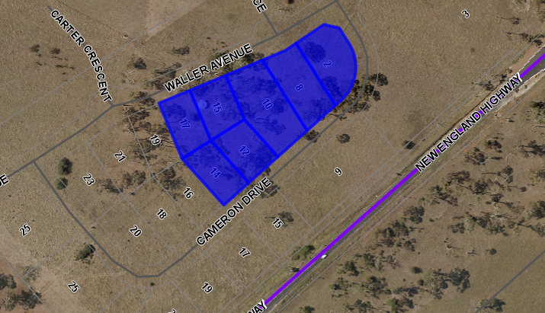

**Figure 1 – Existing lot layout**

There are no significant planning constraints, special features or environmental constraints affecting the site.

The site is burdened by an easement for drainage of sewage 3 wide along the southern boundary of lots 109, 110, 112, 113 and the south western corner of lot 111 and along the northern boundary of Lots 107, 108,109 and partly Lot 110. The proposed development does not impede on the easement.

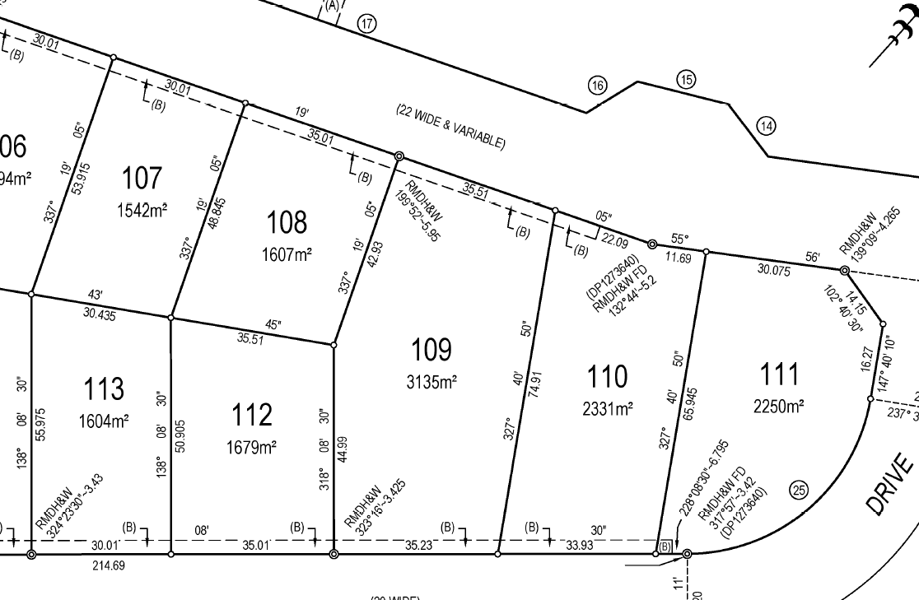

* 1. **The Locality**

In proximity to the site is the Armidale Regional Airport, ancillary aerodrome services and hangers as well as two (2) service stations.

Land immediately adjoining the site, is also zoned IN2 Light Industrial as well as land adjacent to the site, on the eastern side of the New England Highway, which is currently under development. Currently the site is adjoined by vacant allotments, with the exception of 19 Waller Ave, Armidale which is currently under construction. Various development approvals have been issued in the Airside Business Park, including a large scale development being the Australian Transport Museum, a $6.4 million regional tourism venture to be constructed adjacent to the subject site at 9 Cameron Drive.

1. **THE PROPOSAL AND BACKGROUND** 
   1. **The Proposal**

The proposed development is for the construction of a warehouse/distribution centre on the site, being lots 107 -113 DP 1277428, known for the purpose of this report as 2 Cameron Drive, Armidale. The proposal is to facilitate the Aero Healthcare business that specialises in wholesale first aid and medical supplies. The proposed building is generally a single storey warehouse structure with the administration area comprising two storeys. The proposal comprises;

* A bulk warehouse area (2,744m2)
* A pick warehouse area (1,627m2)
* Dispatch and loading dock (246m2)
* Fire Safe room (42m2)
* Lab (23m)
* Supervisor office (9m2)
* Ground Floor Administration/office (248m2)
* First Floor Administration/office (880m2)
* Ground Floor production area (629m2)

The production area is for the assembly/packaging/labelling of individual components picked from the warehouse. The ground floor administration area includes amenities, a gym/recreation room, kitchen and breakout and studio. The first floor administration level comprises a reception area, office, multiple meeting rooms, kitchen/breakout area and amenities.

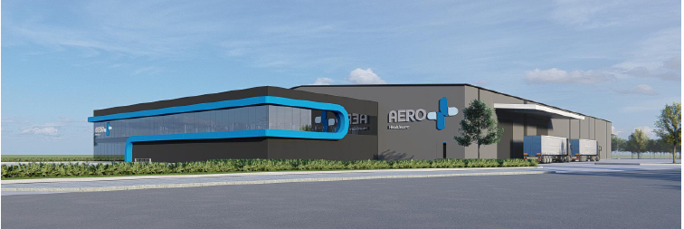

**Figure 2 – Proposed development looking south east from the corner of Waller Ave and Cameron Drive**

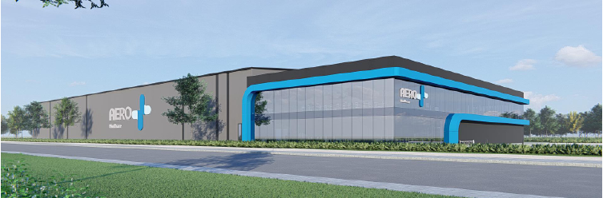

**Figure 3 – the proposed development looking south west from Cameron Drive.**

The proposal includes extensive landscaping and concrete hardstand areas for car parking and circulation as well as rainwater tanks, waste storage area and fire pump along the western boundary.

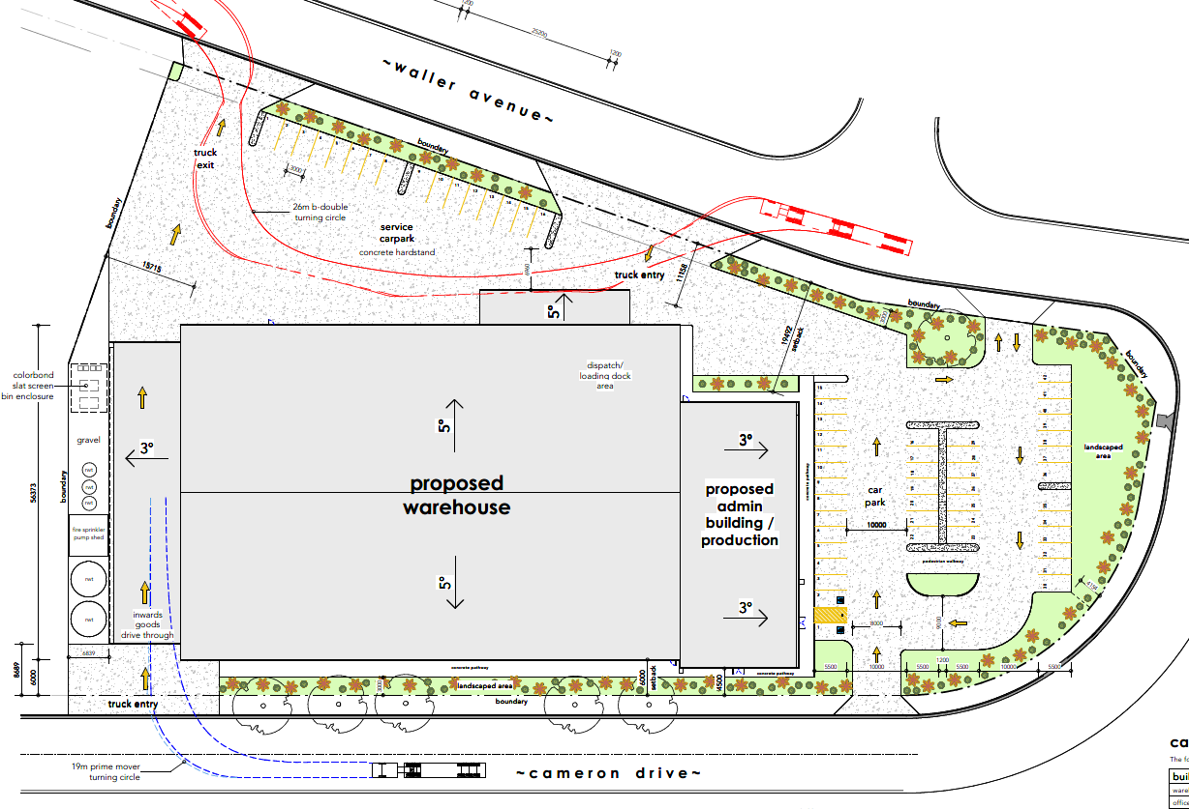

**Figure 4 – proposed site layout**

Amalgamation of the lots that comprise the site is underway, under SC-19-2022. It is recommended that a condition of consent is imposed ensuring consolidation of the lots has occurred prior to the release of an occupation certificate for the development.

**Table 1: Development Data**

|  |  |
| --- | --- |
| **Control** | **Proposal** |
| Site area | 14,148m2 |
| GFA | 6,550m2  Ground Level – 5,650m2  First Floor – 900m2 |
| Clause 4.6 Requests | No |
| Max Height | 12.15m |
| Landscaped area | 1,675m2 |
| Car Parking spaces | 58 car parking spaces including 2 disabled |
| Setbacks | Complies with the setback provisions of the development control plan with the exception of a minor non-compliance on the southern boundary which is considered acceptable. |

* 1. **Background**

A pre-lodgement meeting was held prior to the lodgement of the application on 28 April 2022 where various issues were discussed. No matters of concern or non-compliances were raised at the pre-lodgement meeting.

The development application was lodged on **1 July 2022**. A chronology of the development application since lodgement is outlined below including briefings, deferrals etc:

**Table 2: Chronology of the DA**

|  |  |
| --- | --- |
| **Date** | **Event** |
| 1 July 2022 | DA lodged |
| 5 July 2022 | Exhibition of the application |
| 5 July 2022 | DA originally referred to Transport for NSW |
| 14 Sep 2022 | DA re-referred to Transport for NSW |
| 25 July 2022 | Request for Information from Council to applicant |
| 26 July 2022 | Information Lodged |
| 29 Aug 2022 | Updated plans provided for Admin/production area |
| 5 Oct 2022 | Response received from Transport for NSW |

* 1. **Site History**

The site is the product of a subdivision approved under DA-46-2017 for the subdivision of 6 lots to create 73 new lots.

There are no previous or outstanding applications of issues on the site. The allotments were created for the purpose of industrial development.

The seven (7) allotments that comprise the site are to be consolidated prior to the issue of an occupation certificate for the development. The lot consolidation has been executed under SC-19-2022 but is yet to be registered. It is recommended that a condition of consent be imposed to ensure the registration is completed prior to the release of any Occupation Certificate.

1. **STATUTORY CONSIDERATIONS**

When determining a development application, the consent authority must take into consideration the matters outlined in Section 4.15(1) of the *Environmental Planning and Assessment Act 1979* (‘EP&A Act’). These matters as are of relevance to the development application include the following:

1. *the provisions of any environmental planning instrument, proposed instrument, development control plan, planning agreement and the regulations*

*(i)  any environmental planning instrument, and*

*(ii)  any proposed instrument that is or has been the subject of public consultation under this Act and that has been notified to the consent authority (unless the Planning Secretary has notified the consent authority that the making of the proposed instrument has been deferred indefinitely or has not been approved), and*

*(iii)  any development control plan, and*

*(iiia)  any planning agreement that has been entered into under section 7.4, or any draft planning agreement that a developer has offered to enter into under section 7.4, and*

*(iv)  the regulations (to the extent that they prescribe matters for the purposes of this paragraph),*

*that apply to the land to which the development application relates,*

1. *the likely impacts of that development, including environmental impacts on both the natural and built environments, and social and economic impacts in the locality,*
2. *the suitability of the site for the development,*
3. *any submissions made in accordance with this Act or the regulations,*
4. *the public interest.*

These matters are further considered below;

It is noted that the proposal is not considered to be:

* Integrated Development (s4.46)
* Designated Development (s4.10)
* Requiring concurrence (s4.13)
* Crown DA (s4.33) - written agreement from the Crown to the proposed conditions of consent must be provided
  1. **Environmental Planning Instruments, proposed instrument, development control plan, planning agreement and the regulations**

The relevant environmental planning instruments, proposed instruments, development control plans, planning agreements and the matters for consideration under the Regulation are considered below.

1. **Section 4.15(1)(a)(i) - Provisions of Environmental Planning Instruments**

The following Environmental Planning Instruments are relevant to this application:

* Biodiversity Conservation Act 2016 (BC Act)
* [*State Environmental Planning Policy (Biodiversity and Conservation) 2021*](https://legislation.nsw.gov.au/view/html/inforce/current/epi-2021-0722)
* [*State Environmental Planning Policy (Industry and Employment) 2021*](https://legislation.nsw.gov.au/view/html/inforce/current/epi-2021-0723)
* [*State Environmental Planning Policy (Planning Systems) 2021*](https://legislation.nsw.gov.au/view/html/inforce/current/epi-2021-0724)
* [*State Environmental Planning Policy (Resilience and Hazards) 2021*](https://legislation.nsw.gov.au/view/html/inforce/current/epi-2021-0730)
* [*State Environmental Planning Policy (Transport and Infrastructure) 2021*](https://legislation.nsw.gov.au/view/html/inforce/current/epi-2021-0732)
* *Armidale Dumaresq Local Environmental Plan 2012*

A summary of the key matters for consideration arising from these Environmental Planning Instruments are outlined in **Table 3** and considered in more detail below.

**Table 3: Summary of Applicable Environmental Planning Instruments**

|  |  |  |
| --- | --- | --- |
| **EPI** | **Matters for Consideration** | **Comply (Y/N)** |
| Biodiversity Conservation Act 2016 | Part 7: Biodiversity assessment and approvals under planning act   * Section 7.2 Development of activity “likely to significantly affect threatened species” * Section 7.3 test for determining whether proposed development or activity likely to significantly affect threatened species or ecological communities, or their habitats * Section 7.4 Exceeding biodiversity offset scheme threshold | Y |
| State Environmental Planning Policy (Biodiversity & Conservation) 2021 | Chapter 4: Koala Habitat Protection 2021 | Y |
| State Environmental Planning Policy (Industry and Employment) 2021 | Chapter 3: Advertising and Signage   * Section 3.6 – granting consent to signage * Section 3.11(1) – matters for consideration | Y |
| State Environmental Planning Policy (Planning Systems) 2021 | Chapter 2: State and Regional Development   * Section 2.19(1) declares the proposal regionally significant development pursuant to Section 3(b) of Schedule 6 as it comprises Council related development over $5million, wherein Council is the owner of the land. | Y |
| SEPP (Resilience & Hazards) | Chapter 4: Remediation of Land   * Section 4.6 - Contamination and remediation has been considered and the proposal is considered satisfactory. | Y |
| State Environmental Planning Policy (Transport and Infrastructure) 2021 | Chapter 2: Infrastructure   * Section 2.122 - Traffic-generating development | Y |
| Proposed Instruments  Armidale Regional Local Environmental Plan | The proposal is consistent with the aims and relevant provisions of the draft instrument. | Y |
| LEP | * Clause 2.3 – Permissibility and zone objectives * Clause 6.1- Earthworks * Clause 6.3 – Airspace Operations * Clause 6.4 – Development in areas subject to aircraft noise * Clause 6.5 - Development within a designated buffer * Clause 6.6 – Essential Services | Y |

***Biodiversity Conservation Act 2016 (BC Act)***

The *Biodiversity Conservation Act 2016* provides for the protection and conservation of threatened species, populations and ecological communities. The BC Act is integrated with the *Environmental Planning and Assessment Act 1979*. Under Part 7 of the BC Act, the development must consider potential impacts to threatened species listed under the Act.

As the site is clear of remnant vegetation and is not identified on the biodiversity values map, it is considered unlikely that the proposal will affect threatened species and a biodiversity development assessment report is not required for the application in accordance with section 7.7(2) of the BC Act.

Given the site does not require any clearing of vegetation, the development would not exceed the biodiversity offset scheme threshold and is therefore not considered to have a significant impact pursuant to Section 7.2(1)(b).

The proposal will not be carried out in a declared area of outstanding biodiversity value pursuant to Section 7.2(1)(c).

Consideration of the relevant SEPPs is outlined below:

[***State Environmental Planning Policy (Biodiversity and Conservation) 2021***](https://legislation.nsw.gov.au/view/html/inforce/current/epi-2021-0722)

Chapter 3: Koala Habitat Protection 2021

The *State Environmental Planning Policy (Biodiversity and Conservation) 2021* applies to the proposal as the site has an area of at least 1 hectare and there is no approved koala plan of management. Notwithstanding this, the site is not identified as being potential koala habitat as there is no vegetation on the site. No further consideration is required.

[***State Environmental Planning Policy (Industry and Employment) 2021***](https://legislation.nsw.gov.au/view/html/inforce/current/epi-2021-0723)

*State Environmental Planning Policy (Industry and Employment) 2021* applies to the proposal. The SEPP requires signage to be compatible with amenity and visual character of an area, provide effective communication in suitable locations and be of high quality design and finish. Pursuant to Clause 8 of the SEPP, proposed signage must be assessed in accordance with the assessment criteria in Schedule 5.

The proposed signage is consistent with the provisions of the SEPP as shown in the compliance table provided in Attachment B.

[***State Environmental Planning Policy (Planning Systems) 2021***](https://legislation.nsw.gov.au/view/html/inforce/current/epi-2021-0724) ***(‘Planning Systems SEPP’)***

Chapter 2: State and Regional Development

The proposal is *regionally significant development* pursuant to Section 2.19(1) as it satisfies the criteria in Section 3(b) of Schedule 6 of the Planning Systems SEPP as it is Council related development over $5 million as Council is the owner of the land. Accordingly, the Northern Regional Planning Panel is the consent authority for the application. The proposal is consistent with this Policy.

[***State Environmental Planning Policy (Resilience and Hazards) 2021***](https://legislation.nsw.gov.au/view/html/inforce/current/epi-2021-0730)

Chapter 4: Remediation of Land

The provisions of Chapter 4 of *State Environmental Planning Policy (Resilience and Hazards) 2021 (‘the* Resilience and Hazards SEPP’) have been considered in the assessment of the development application. Section 4.6 of Resilience and Hazards SEPP requires consent authorities to consider whether the land is contaminated, and if the land is contaminated, it is satisfied that the land is suitable in its contaminated state (or will be suitable, after remediation) for the purpose for which the development is proposed to be carried out.

The subject site is identified on Councils mapping as potentially contaminated land. Notwithstanding this, this constraint applies to whole Airside Business Park and Airport precinct.

A Preliminary Site Investigation was conducted under DA-46-2017 for the subdivision that created the allotment. The report identified potential sources of contamination resulting from previous agricultural uses. These uses were carried out on land known as Stage 2 of the Airside Business Park which is not the subject site or not directly adjacent to the site.

As the matter was considered in detail during the assessment of DA-46-2017 further investigation is not required as it is considered the site is suitable for the proposed development.

[***State Environmental Planning Policy (Transport and Infrastructure) 2021***](https://legislation.nsw.gov.au/view/html/inforce/current/epi-2021-0732)

Chapter 2: Infrastructure

State Environmental Planning Policy (Transport and Infrastructure) 2021 applies to the proposal as the proposal is deemed a traffic generating development under Schedule 3 of the SEPP as below:

|  |  |  |
| --- | --- | --- |
| Warehouse or distribution centres | Size or capacity – site with access to a road (generally) | Size or capacity – site with access to classified road or to road that connects to classified road |
| 8,000m2 in site area or (if the site area is less than the gross floor area) gross floor area | 8,000m2 in site area or (if the site area is less than the gross floor area) gross floor area |

Pursuant to schedule 3 of the SEPP the proposal required referral to Transport for NSW who raised no objection to or requirements for the proposed development.

***Armidale Dumaresq Local Environmental Plan 2012***

The relevant local environmental plan applying to the site is the *Armidale Dumaresq Local Environmental Plan 2012* (‘the LEP’). The aims of the LEP include;

1. To encourage the orderly management, development, and conservation of resources by protecting, enhancing and conserving

The proposal is consistent with these aims of the LEP.

*Zoning and Permissibility (Part 2)*

The site is located within the IN2 Light Industrial Zone pursuant to Clause 2.2 of the LEP.

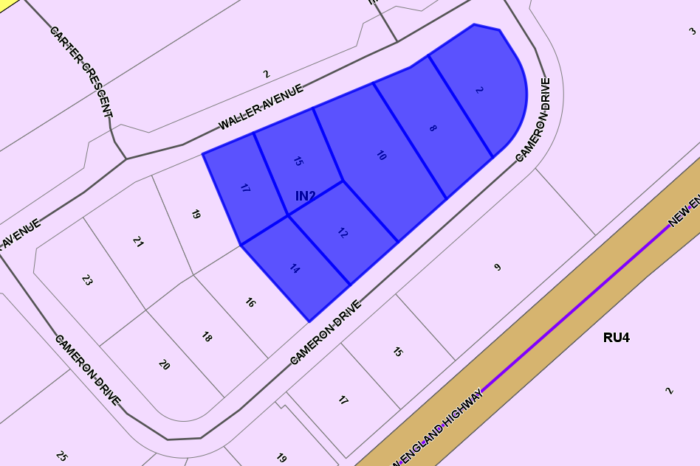

**Figure 5 – Zoning Map**

The proposed development is defined as a ***warehouse or distribution centre.***

***Warehouse or distribution centre*** *means a building or place used mainly or exclusively for storing or handling items (whether goods or materials) pending their sale, but from which no retail sales are made.*

According to the definitions in Clause 1.4 (contained in the Dictionary), the proposal satisfies the definition of ***warehouse or distribution centre*** which is a permissible use with consent in the Land Use Table in Clause 2.3.

The IN2 Light Industrial zone objectives include the following (pursuant to the Land Use Table in Clause 2.3):

* *To provide a wide range of light industrial, warehouse and related land uses*
* *To encourage employment opportunities and to support the viability of centres*
* *To minimise any adverse effect of industry on other land uses*
* *To enable other land uses that provide facilities or services to meet the day to day need of the workers in the area*
* *To support and protect industrial land for industrial uses*

The proposal is considered to be consistent with these zone objectives for the following reasons:

* The proposal provides a warehouse use, that will not adversely impact future development on adjoining land, and
* The proposal is not contrary to any of the objectives of the zone.

*General Controls and Development Standards (Part 2, 4, 5 and 6)*

The LEP also contains controls relating to development standards, miscellaneous provisions and local provisions. The controls relevant to the proposal are considered in **Table 4** below.

**Table 4: Consideration of the LEP Controls**

|  |  |  |  |
| --- | --- | --- | --- |
| **Control** | **Requirement** | **Proposal** | **Comply** |
| Earthworks  (Cl 6.1) | To ensure that earthworks will not have a detrimental impact on environmental functions and processes, neighbouring uses, cultural or heritage items or features surrounding the land | The extent of earthworks required of the development will not impact on adjoining allotments or impact on environmental functions.  Standard conditions for erosion and sediment control measures will be imposed as well as conditions relating to the uncovering of aboriginal relics during construction. | Yes |
| Airspace Operations  (Cl 6.3) | Provide for the effective and ongoing operation of the Armidale Regional Airport by ensuring operation is not compromised by development that penetrates the Limitation or Operations Surface of that Airport | The development will not penetrate the Obstacle Limitations or Operations Surface Plan for the Armidale Regional Airport as the ridgeline of the development is 12.15m.  A condition will be imposed for a survey to confirm no penetration of the OLS. | Yes |
| Development in areas subject to aircraft noise  (Cl 6.4) | To prevent certain noise sensitive developments from being located near the Armidale Regional airport and its flight paths and to assist in minimising the impact of aircraft noise from the airport and its flight path and to ensure that land use in the vicinity of the airport does not hinder or have any adverse impacts on the ongoing, safe and efficient operation of the airport. | The proposed development is not for a residential purpose and not considered a sensitive receptor to the operations of the airport or the flight paths. The proposal will not affect the operation of the airport. | Yes |
| Development within a designated buffer  (Cl. 6.5) | To maintain a safe and effective operational environment around the Armidale Regional Airport. | The proposed development will not impact on the effective operation of the Armidale Regional Airport.  A condition is to be imposed, ensuring any outdoor lighting on the building or the site is designed by a suitably qualified professional and is in accordance with CASA guidelines, so to not impact on the operation of the Airport. | Yes |
| Essential Services  (Cl. 6.6) | The consent authority must be satisfied that the following services that are essential for the development are available;   1. The supply of water, 2. The supply of electricity 3. The disposal and management of sewage 4. Storm water drainage or on-site conservation 5. Suitable road access | 1. The development is to be connected to reticulated water supply 2. Connection to electricity is available to the site through existing underground infrastructure. 3. The development is to be connected to reticulated sewer 4. Storm water infrastructure was considered as part of the subdivision under DA-46-2017. The development will be connected to this existing infrastructure. Stormwater detention has been provided throughout the business park to eliminate the requirement for individual lots to install systems on each lot. 5. The site has legal and suitable road access to Cameron Drive and Waller Ave | Yes |

The proposal is considered to be generally consistent with the ADLEP.

1. **Section 4.15 (1)(a)(ii) - Provisions of any Proposed Instruments**

The following proposed instrument, which has been the subject of public consultation under the EP&A Act, and is relevant to the proposal:

* *Draft Armidale Regional Local Environmental Plan 2022*

The proposed instrument is considered below:

The *Draft Armidale Regional Local Environmental Plan 2022* is a consolidation of the Armidale Dumaresq Local Environmental Plan 2012 and the Guyra Local Environmental Plan 2012. The proposal was considered against the provisions of the draft instrument, wherein there are no changes proposed to the land use zone or table that impact the subject proposal.

The proposal is consistent with these provisions of the draft instrument.

1. **Section 4.15(1)(a)(iii) - Provisions of any Development Control Plan**

The following Development Control Plan is relevant to this application:

* *Armidale Dumaresq Development Control Plan 2012* (‘the DCP’)

The proposed development is generally consistent with the relevant chapters of the DCP, in particular Chapter 5.2 Industrial Development with the exception of a minor noncompliance with Section 3.2 Setbacks. In this instance the non – compliance is considered acceptable.

Discussion regarding the non-compliance is provided in the table of compliance provided in Attachment B.

The following contributions plans are relevant pursuant to Section 7.18 of the EP&A Act and have been considered in the recommended conditions (notwithstanding Contributions plans are not DCPs they are required to be considered):

* *Armidale Regional Council S7.12 Contributions Plan 2018*

This Contributions Plan has been considered and the land is currently mapped as excluded land for the purposes of s7.12 contributions and as such s7.12 contributions are not levied on this development.

1. **Section 4.15(1)(a)(iiia) – Planning agreements under Section 7.4 of the EP&A Act**

There have been no planning agreements entered into and there are no draft planning agreements being proposed for the site.

1. **Section 4.15(1)(a)(iv) - Provisions of Regulations**

Section 61 of the 2021 EP&A Regulation contains matters that must be taken into consideration by a consent authority in determining a development application.

There are no matters relevant to the application.

Section 62 (consideration of fire safety) and Section 64 (consent authority may require upgrade of buildings) of the 2021 EP&A Regulation not relevant to the proposal.

* 1. **Section 4.15(1)(b) - Likely Impacts of Development**

The likely impacts of the development, including environmental impacts on both the natural and built environments, and social and economic impacts in the locality must be considered. In this regard, potential impacts related to the proposal have been considered in response to SEPPs, LEP and DCP controls outlined above and the Key Issues section below.

The consideration of impacts on the natural and built environments includes the following:

Context and setting

* The proposal is considered to be consistent with the approved and future expected development in the locality. The Airside Business Park is an appropriate setting for a development of this scale given the availability of servicing, infrastructure and connectivity to the key transport corridor of the New England Highway.
* The design of the proposed development and the site layout is considered suitable for the site and will be compatible with future development.

Access and traffic

* The proposal was referred to Transport for NSW under Schedule 3 of the SEPP (Transport and Infrastructure) 2021 wherein no objections were raised or requirements for conditions.

Consideration of the traffic and access report raised no concerns and Council is satisfied that there is adequate access and circulation area available on site for the intended vehicular movements.

Public Domain

* The proposed building will not have an adverse visual impact on the streetscape or the adjoining Airside Business Park. The design and materiality of the building is diverse and to be of a high finish that will complement future development.

Utilities

* The subject site has the availability to connect to all essential services and has legal and suitable vehicular access from both Waller Ave and Cameron Drive.

Heritage

* The site is not identified as a heritage item, does not lie within a heritage conservation area and is not within the curtilage of a heritage item.
* There are no known Aboriginal heritage sites located on the site or in proximity. An AHIMS search was undertaken which found no nearby artefacts.
* The agricultural history of the site is sufficient evidence that the site is classified as ‘disturbed’ under the “Due Diligence Code of Practice for the Protection of Aboriginal Objects in NSW”.
* As a result of this, and the AHIMS search that has been carried out finding no nearby artefacts, it is determined that the project will have no impact on Aboriginal objects.
* As such, no further investigations are required.

Other land resources

* The site is not affected by or located in an area of significant natural resources such as water, mining, or significant agricultural land.

Flora and fauna impacts

* The site is clear of vegetation with the exception of disturbed grass that is the result of works carried out for the subdivision that created the allotment. Potential impacts to flora and fauna have been considered and it is determined that the proposed development will not have an impact.

Natural environment

* There will be no significant changes to the topography of the site or natural environment as a result of the proposed development.

Noise and vibration

* The earthworks required for the proposed development will not require boring or works that would generate high levels of noise and vibration that could impact adjoining allotments. The nearest sensitive receptor, being a residential allotment is approximately 220m from the site. It is considered that this receptor will experience an increase in noise levels during construction hours, however there is not considered to be an adverse impact as a result. Construction hours are to be in accordance with the standard construction hours:
* Monday to Friday 7.00am to 6.00pm
* Saturday 8.00am to 1.00pm
* No work on Sunday or public holidays
* Once works are completed the operation of the proposed development will be limited to vehicle movements, idling trucks, mechanical ventilation for the building and waste collection.
* The site is in proximity to the Armidale Regional Airport and the New England Highway which are noise generating sources throughout business hours, however it is considered that the proposed development is not a sensitive receptor to noise and there will be no adverse impacts on the development that requires mitigation.

Natural hazards

* The site is not affected identified as flood prone land and is not identified as bushfire prone land. There are no natural hazards affecting the site.

Safety, security and crime prevention

* The proposal has considered crime prevention through environmental design with proposal elements such as secure parking, the building and site layout and landscaping and lighting.
* No concerns are raised regarding safety and security on site or for adjoining allotments as a result of the development.

Social impact

* There is not considered to be a direct social impact as a result of the proposed development.

Economic impact

* The proposed development is considered to have a positive economic benefit through the development of multiple lots in the Airside Business Park, the expansion of an existing local business and the local expenditure that will occur during construction.
* The purchase of lots in the Airside Business Park, provides revenue for Council to continue to provide essential services and community facilities. A development of this scale can further act as a catalyst for industrial development in the Armidale Region and increase the attractiveness of doing business in Armidale.

Site design and internal design

* The design of the building and layout across the site is considered suitable for the use and the nature of the site as a corner allotment. The site comprises an extensive area of landscaping and hardstand area that increases the setback between the proposal and future adjoining development on smaller lots. The internal design is satisfactory in that ample landscaping is provided whilst allowing adequate vehicle circulation area.

Construction

* There are not considered to be any issues arising from the construction of the proposed development on adjoining properties. Standard conditions of consent relating to hours of work and erosion sediment controls will be imposed.

Cumulative impacts

* The proposal is pursuant with the Armidale Dumaresq Local Environmental Plan 2012 and generally consistent with the controls of the Armidale Dumaresq Development Control Plan 2012, with the exception of a minor noncompliance with the setback control in Chapter 5.2 of the DCP.

This non-compliance will not have an adverse impact and does not have the potential to result in cumulative impacts to adjoining development. The non-compliance is minor and has been adequately mitigated on site through the use of landscaping.

Accordingly, it is considered that the proposal will not result in any significant adverse impacts in the locality as outlined above.

* 1. **Section 4.15(1)(c) - Suitability of the site**

The site is considered suitable for the proposed development for the following reasons:

* The site is zoned IN2 Light Industrial wherein the proposed warehouse or distribution centre is permitted with consent
* The proposal is considered consistent with the development and intended character of the Airside Business Park. The scale and design of the development is considered appropriate for the size of the site.
* The site is vacant of vegetation and is unaffected by natural hazards such as bushfire and flooding.
* The site has connection to essential services and utilities to service the development
* The proposal complies with the relevant buffers and clearances for airspace operations associated with the nearby Armidale Regional Airport.
* The topography of the site and the corner location are conducive to the development as the allotment requires limited earthworks and provides dual street frontage for access
  1. **Section 4.15(1)(d) - Public Submissions**

No submissions were received during the exhibition of the application.

* 1. **Section 4.15(1)(e) - Public interest**

The proposed development is considered consistent with the public interest as detailed in this report. The proposal is consistent with the aims and relevant provisions of the LEP and other relevant statutory considerations. The proposal will not adversely affect the safety and amenity of the public and is not likely to result in any future land use conflicts.

1. **REFERRALS AND SUBMISSIONS** 
   1. **Agency Referrals and Concurrence**

The development application has been referred to Transport for NSW as required by the EP&A Act and outlined below in Table 5.

There are no outstanding issues arising from the referral requirements. No conditions are recommended.

**Table 5: Concurrence and Referrals to agencies**

|  |  |  |  |
| --- | --- | --- | --- |
| **Agency** | **Concurrence/**  **referral trigger** | **Comments**  **(Issue, resolution, conditions)** | **Resolved** |
| Concurrence Requirements (s4.13 of EP&A Act) (if none – N/A – to show consideration) | | | |
| No concurrence under s4.13 of the EP&A Act is required. | | | |
| Referral/Consultation Agencies | | | |
| Transport for NSW | Section 2.122 – *State Environmental Planning Policy (Transport and Infrastructure) 2021*  Development that is deemed to be traffic generating development in Schedule 3. | TfNSW raised no objection to or requirements for the proposed development as it considered there will be no significant impact to the New England Highway (Classified Road).  Comments:  A total of five (5) site accesses, three (3) being to Waller Ave and two (2) ingress only from Cameron Drive,  TfNSW recommends the consideration, of the consolidation of access to improve road safety and efficiency within the industrial subdivision.  TfNSW recommends the consideration of the extension of the existing footpath network along all road frontages of the development site to enable future links between the site and the existing public and active transport infrastructure. | Y |
| Integrated Development (S 4.46 of the EP&A Act) | | | |
| The proposed development is not Integrated Development under s.4.46 of the EP&A Act. | | | |

* 1. **Council Officer Referrals**

The development application has been referred to various Council officers for technical review as outlined **Table 6.**

**Table 6: Consideration of Council Referrals**

|  |  |  |
| --- | --- | --- |
| **Officer** | **Comments** | **Resolved** |
| Engineering | Council’s Engineering Officer reviewed the traffic and car parking study and raised no objections. | Yes |
| Building | Council’s Building Surveyor reviewed the application and the BCA compliance report provided. A Section J report is required and will be required at the CC stage. A condition of consent will be imposed. | Yes |

No issues were raised by Council officers.

* 1. **Community Consultation**

The proposal was notified in accordance with the Council’s Community Participation Plan from 5 July 2022 until 20 July 2022. The notification included the following:

* Notification on Council’s website;

No submissions were received.

1. **KEY ISSUES**

No key issues have been identified during the assessment of the proposal.

1. **CONCLUSION**

This development application has been considered in accordance with the requirements of the EP&A Act and the Regulations as outlined in this report. Following a thorough assessment of the relevant planning controls, it is considered that the application can be supported.

Recommended draft conditions are provided in **Attachment A**.

1. **RECOMMENDATION**

That the Development Application DA-92-2022 for a *warehouse or distribution centre* at 2 Cameron Drive, Armidale be APPROVED pursuant to Section 4.16(1)(a) of the *Environmental Planning and Assessment Act 1979* subject to the draft conditions of consent attached to this report at Attachment A.

The following attachments are provided:

* Attachment A: Draft Conditions of consent
* Attachment B: Tables of Compliance
* Attachment C: Architectural Plans